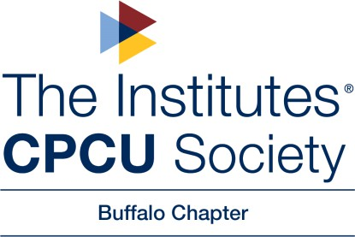

Dear Local Business,

The Buffalo Chapter of the CPCU society is hosting a Night at the Races on July 12, 2025, at The Fairgrounds in Hamburg, NY. During the event, we will be running a basket raffle and Special Items Auctions along with assorted door prize giveaways.

We are contacting you to see if you would agree to donate an item that we could use as an auction item or door/giveaway prize during this worthwhile event. The money raised will be used to support the Center for Hope WNY, our scholarship fund and our local chapter.

We understand you get many, many requests for donations and appreciate your kindness and generosity.

Chauncey Carter

Buffalo CPCU Chapter President